**Aim**

To write a C program to reverse the digits of a 32-bit signed integer and check for overflow conditions.

**Algorithm**

1. Start.
2. Input an integer x.
3. Initialize rev = 0.
4. Repeat while x != 0:
   * Extract the last digit using digit = x % 10.
   * Remove the digit from x using x = x / 10.
   * Add digit to reverse: rev = rev * 10 + digit.
   * If rev goes beyond 32-bit signed integer range, return 0.
5. Print the reversed number.
6. Stop.

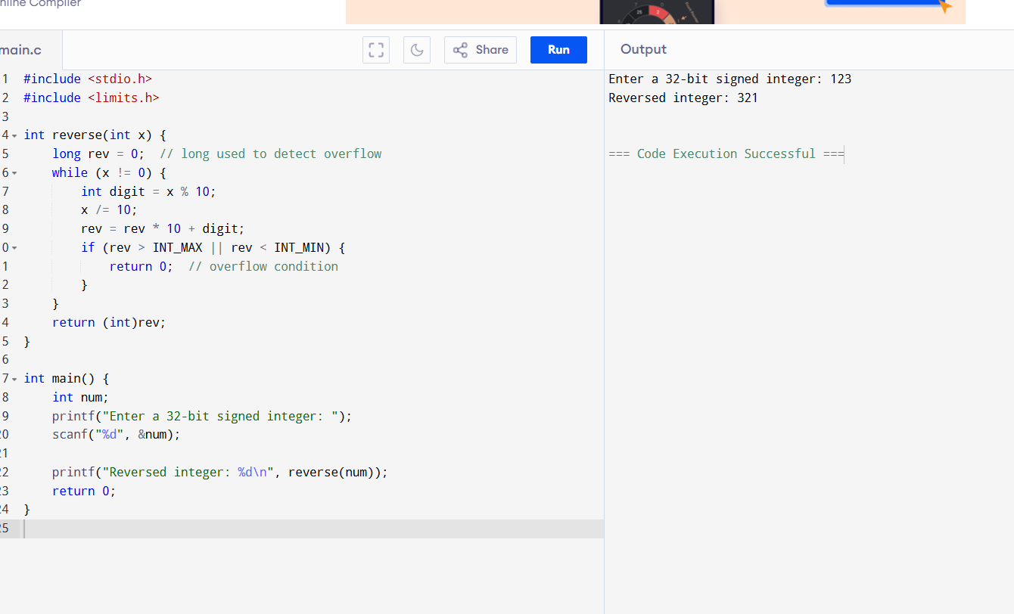

**Result**

The program to reverse the digits of a 32-bit signed integer was successfully executed.  
It correctly returns the reversed number for valid cases and 0 when the result exceeds the 32-bit signed integer range.